Determine the following information about polynomial functions:
- ) f(x) = -0.1x³ + 0.2x² + 2.9x -3
- Find the zeros of the function: x = 6, x=1, x = -5
- Find where f (x) < 0: [-5, 1]
- Find and Classify the Extrema:
The Extrema means the maximum and the minimum value of f (x).
The minimum of -0.1x³ + 0.2x² + 2.9x -3 is (-2.45, -7.43).
The maximum of -0.1x³ + 0.2x² + 2.9x -3 is (3.87, 5.42).
- Give the intervals of increasing: [-2.45, 5.42]
- Give the intervals of decreasing: [-6.11, -2.45)(5.42, -9.60]
- Find the y-int: The y intercept is (0, -3)
- Describe in your own words what extrema are:
The extrema of a function f are the where the function f is either a maximum or a minimum.
Let f be a function defined on the interval (a,b) with the point c. Then
i.) f has a minimum at c if f (c) < f (x) for all x in (a,b).
ii.) f has a maximum at c if f (c) > f (x) for all x in (a,b).

- g(x) = 0.01x⁴ + 0.01x³ – 0.39x² + 0.31x + 0.7
- Find the zeros of the function: the zeros of the function are
X = -1
X = 2
X = 5
- Find where g(x) ≥ 0: [ -∞, -7)(-1, 2)(5, ∞]

- Find and Classify the Extrema:

The extrema of a function is the maximum and the minimum of its value hence for the function g(x) = 0.01x⁴ + 0.01x³ – 0.39x² + 0.31x + 0.7, the
Maximum is (0.24, 0.75)
Minimum is (-5.00, -5.60)

- Give the intervals of increasing: [-5, -1)(-1, 0.4)(5, +∞]
- Give the intervals of decreasing: [-∞, -5.0)(0.4, 4.0]
- Find the y-int: the y intercept is (0, 0.7)
- ) Describe in your own words what a polynomial function is:
A polynomial function has the form and is a mathematical expression that involves the sum of terms, each term including a variable or several variables raised to a certain power and multiplied by a variable.
- What is the fundamental Theorem of Algebra and how does it apply to polynomials?
If P (x) is a polynomial function of degree n ≥ 1, then P (x) = 0 has exactly n roots, including multiple and complex roots. The fundamental theorem of algebra states that the degree of the polynomial equation informs you of the number of the roots the equation will have.

Sketch a polynomial on each coordinate plane that satisfies the given characteristics:
6.) A degree 2 polynomial with a negative leading and one real root.
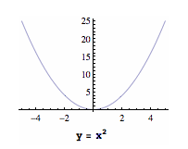
7.) A degree 3 polynomial with a positive leading coefficient and two real roots.
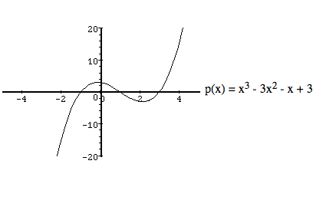
8.) A degree 4 polynomial with a negative leading coefficient and two real solutions.

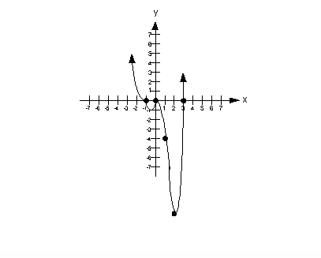
9.) A degree 5 polynomial with 3 real roots and a positive leading coefficient.
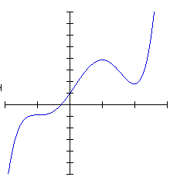

10.) A degree 7 polynomial with a positive leading coefficient and three real roots: 1 with odd multiplicity and 2 with even multiplicity.
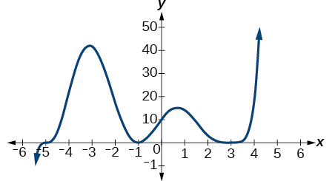
11.) A degree 6 polynomial with a negative leading coefficient and only one real root with multiplicity 3.
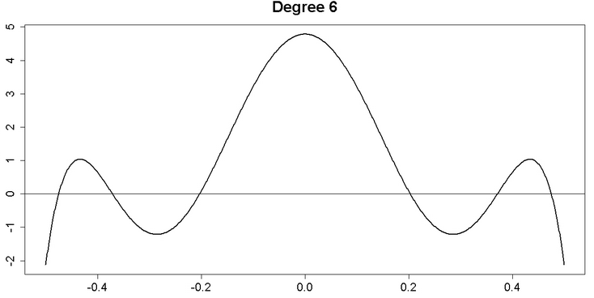
12. Determine the following information about the given graph of the function h (x):

Find the intervals of increasing: [-10, -6)(0, 5]

Find the intervals of decreasing: [-3, 0)(7, -5]

Find the intervals of constant: [-6, -3)(4, 7)(9, 10]

Find the zeros of the function: The zeros of a function occur when f(x) = y = 0 hence for this graph the zeros of the function is x = 2, x = 8.

Find the y-intercept of the function:
13.) Find all the complex zeros of the following polynomial using long or synthetic division:
y = x⁴ – 6x³ + 26x² – 46x + 65
Answer:
The complex zeros of this function are:
The complex zeros are:
65i and -65i

14.) Sketch the following polynomial and describe the multiplicities of its zeros:
y = -0.000002(x + 4)³(x - 1)²(x - 7)⁵
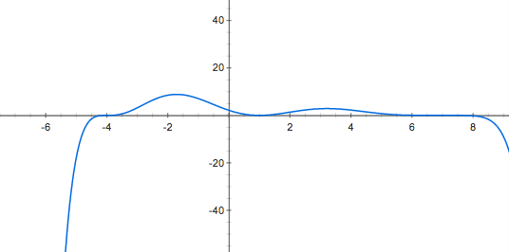
Degree: the above polynomial is of degree 5
Zeros: x = 7
X = 1
X = -4
Bonus: What type of extrema do you call a zero with odd multiplicity?
Answer:
The type of extrema that is called a zero with odd multiplicity is simple zero.

